Meiosis Study Guide
Level 2 Vocabulary
Meiosis I (and all stages)
Meiosis II (and all stages)
Gamete
Diploid (2n)
Haploid (1n)
Homologous Chromosomes
Tetrad
Chiasma
Crossing Over
Recombination
Sister Chromatids
Chromosomal Disorders
Level 3 Practice Questions
- Draw how random alignment of chromosomes during metaphase 1 can create diverse gametes. ***Show 2 separate examples of meiosis, where the chromosomes are aligning differently in each example.
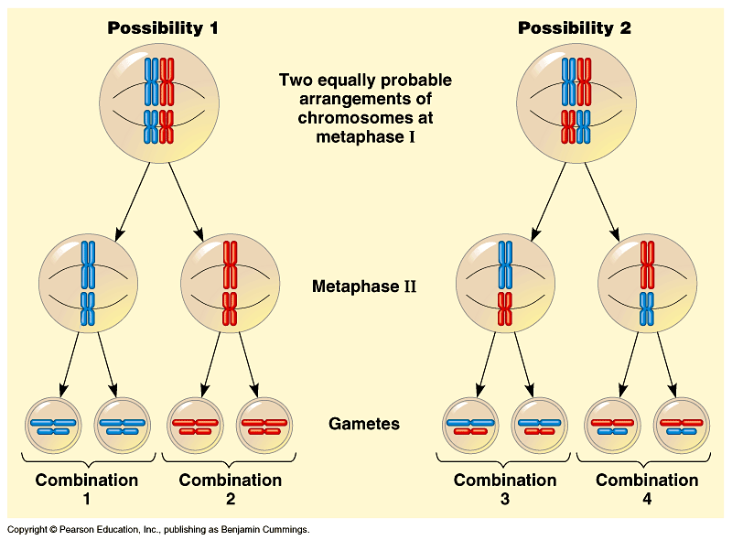

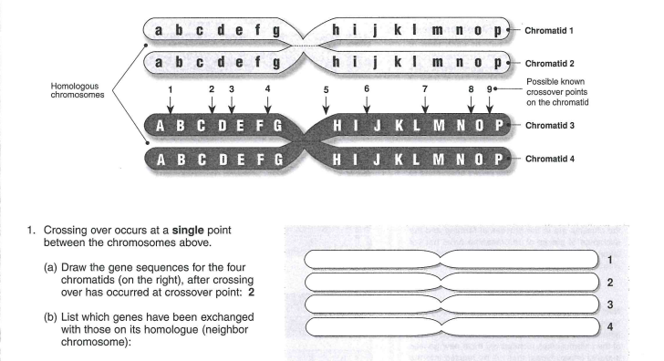

This problem is saying that a chiasma is forming between the letters C and D. Just like our drawings in class, only the 2 strands on the inside will get tangled in the chiasma. So, when you draw the new chromosomes, the A, B, and C alleles of the 2 inside strands are going to swap places. They should look like this:
a b c d e f g h I j k l m n o p
A B C d e f g h I j k l m n o p
a b c D E F G H I J K L M N O P
A B C D E F G H I J K L M N O P

- Why is it important for eggs and sperm to be haploid?
They need to be haploid so that when a sperm fertilizes an egg, the resulting zygote (baby cell) will be diploid. If the egg and sperm were not haploid, they would cause aneuploidy in the offspring.

Practice Level 4 Questions
- Draw 2 ways that meiosis could go wrong! Then, name and describe the disease that would result from the mutation you drew.

You could draw nondisjunction during any step of meiosis here! (for examples, look at picture below.) Then, look up what disorder the gametes would have using the sex chromosome disorder chart.
